**Topics: Descriptive Statistics and Probability**

1. Look at the data given below. Plot the data, find the outliers and find out $μ, σ, σ^{2}$

|  |  |
| --- | --- |
| **Name of company** | **Measure X** |
| Allied Signal | 24.23% |
| Bankers Trust | 25.53% |
| General Mills | 25.41% |
| ITT Industries | 24.14% |
| J.P.Morgan & Co. | 29.62% |
| Lehman Brothers | 28.25% |
| Marriott | 25.81% |
| MCI | 24.39% |
| Merrill Lynch | 40.26% |
| Microsoft | 32.95% |
| Morgan Stanley | 91.36% |
| Sun Microsystems | 25.99% |
| Travelers | 39.42% |
| US Airways | 26.71% |
| Warner-Lambert | 35.00% |

Ans: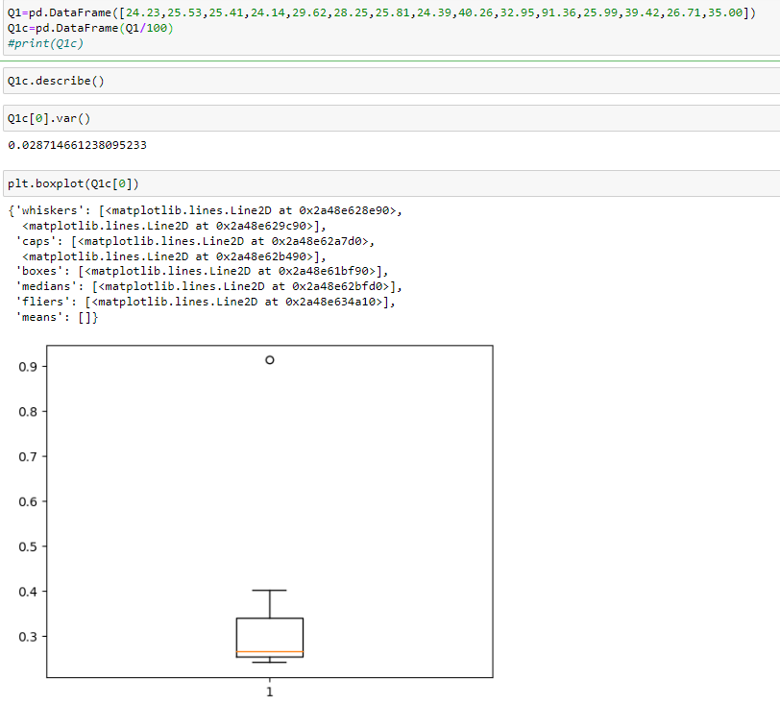

Mean = 0.332713 SD = 0.169454 Var = 0.028714661238095233



Answer the following three questions based on the box-plot above.

1. What is inter-quartile range of this dataset? (please approximate the numbers) In one line, explain what this value implies.

Ans: IQR= Q3-Q1= 12-5 = 7

It implies Quartile 2 (or) median

1. What can we say about the skewness of this dataset?

Ans: It is Right / Positive Skewed

1. If it was found that the data point with the value 25 is actually 2.5, how would the new box-plot be affected?

Ans: There will be not Outlier



Answer the following three questions based on the histogram above.

1. Where would the mode of this dataset lie?

Ans: Mode lies in between 4-8

1. Comment on the skewness of the dataset.

Ans: The dataset is Right/Positively skewed

1. Suppose that the above histogram and the box-plot in question 2 are plotted for the same dataset. Explain how these graphs complement each other in providing information about any dataset.

Ans: Both are Right Skewed and have a outlier at 25

1. AT&T was running commercials in 1990 aimed at luring back customers who had switched to one of the other long-distance phone service providers. One such commercial shows a businessman trying to reach Phoenix and mistakenly getting Fiji, where a half-naked native on a beach responds incomprehensibly in Polynesian. When asked about this advertisement, AT&T admitted that the portrayed incident did not actually take place but added that this was an enactment of something that “could happen.” Suppose that one in 200 long-distance telephone calls is misdirected. What is the probability that at least one in five attempted telephone calls reaches the wrong number? (Assume independence of attempts.)

Ans:

Probability of Call Misdirecting = 1/200

Probability of Call not Misdirecting = 1 - 1/200 = 199/200

Number of Calls = 5

Using Binomial Distribution formula i.e nCr Pr  Qn-r to find 1 in 5 calls reaches the wrong number

=5C1 (1/200)1 (1-1/200)5-1 = 0.024751246878125

OR

1-(1/200)5 = 0.024751246878125

1. Returns on a certain business venture, to the nearest $1,000, are known to follow the following probability distribution

|  |  |
| --- | --- |
| x | P(x) |
| -2,000 | 0.1 |
| -1,000 | 0.1 |
| 0 | 0.2 |
| 1000 | 0.2 |
| 2000 | 0.3 |
| 3000 | 0.1 |

1. What is the most likely monetary outcome of the business venture?

Ans. The most likely monetary outcome is 2000 as it has highest probabilit

1. Is the venture likely to be successful? Explain

Ans. Yes, Because there is 60% chance to give Profits and 20% chance of

failure and 20% chance for no loss and no profit

1. What is the long-term average earning of business ventures of this kind? Explain

Ans. (-2000*0.1) +(-1000*0.1) +(0*0.2) +(1000*0.2) +(2000*0.3) +

(3000*0.1) =800

The long-term average earning for these types of ventures would be $800

1. What is the good measure of the risk involved in a venture of this kind? Compute this measure

Ans. Good measure of the risk = Standard Deviation

Variance = E(X²)  - ( E(X) )² where E(X2)=X2*P(x) & (E(X))2 =( X*P(x))2

Variance = 2160000

SD = Sqrt(variance) = Sqrt(2160000) = 1469.6938456699068

The venture is at high risk because the standard deviation ($1870) >

average return ($800)